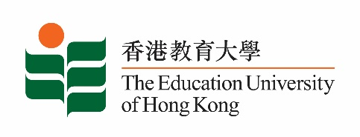
致： 传媒机构采访主任 (共 1页) 20 May 2022
To : News Editors (total: 1 page)

香港教育大学2022年5月23日至6月5日可供采访之活动一览
The Education University of Hong Kong (EdUHK) Events Calendar for 23 May to 5 June 2022
本校诚邀 贵机构派员采访下列活动。传媒查询，请联络教大传讯处（电话：2948 6050）。
You are cordially invited to cover the events below. For media enquiries, please contact the Communications Office at 2948 6050.

因应2019冠状病毒疫情，以下活动或有人数限制，传媒请预先向主办部门登记。
In light of the COVID-19 pandemic, there may be restrictions on the number of participants for the following event(s). Please contact the respective organiser(s) / department(s) for prior registration.

日期  Date | 时间  Time | 活动  Event | 地点  Venue | 主办部门及公众查询  Organiser &  Public Enquiry | 备注  Remarks
2022-06-01 –  2022-06-17 | 平日：  Weekdays:  12 noon – 7 pm  周末及公众假期：  Weekends and Public Holiday: 11 am – 8 pm | 「西油记」小区艺术展览  “Journey to West Kowloon” Community Art Exhibition | 西九文化区艺术展亭  Arts Pavilion, West Kowloon Cultural District | 主办部门 / Organiser:  文化与创意艺术学系  Department of Cultural and Creative Arts  香港旅游发展局  Hong Kong Tourism Board  查询 / Enquiries:  何旸博士Dr Sunnie He Yang  电话 / Tel :  2948 8360 | 详情/ Details:  https://www.discoverhongkong.com/eng/what-s-new/events/detail.id78612.-%E8%A5%BF%E6%B2%B9%E8%A8%98-%E8%97%9D%E8%A1%93%E5%B1%95%E8%A6%BD.html

